Income Distribution
Student Name:
Institution Affiliation:

Income Distribution
Introduction
The equality to which income is dealt with among the members if the society is commonly referred to as community distribution income distribution can be termed to be equal if all the members of the society have the same amount of money. Incomes of most nations are usually perfectly unequal since they do not have, members, having the same income amounts. Mostly the level of income distribution in most countries is at the middle between the unequal and equal. Income distribution is essential in the determination of the economic state of a nation. Inequality in the distribution of wealth is majorly associated with bringing adverse effects to the economic status of the nation. The economic growth and development of a country will also largely depend on income distribution.
Income Distribution Trends in the United States
According to the Sentier Research (A united based economic research firm), the current United States median household income is $62,175. According to the firm, the United States income has never consisted since time in history. Using their estimates, the median household income has shifted on a monthly basis by either increasing or reducing. However, a remarkable increase of income distribution in the nation has been noted from 2000 ton2018. The firm’s monthly median household income estimates have raised since $40,597 to $62,175. Between the year 2008 and 2011, a significant reduction in the income distribution was experienced. The median household income reduced from $51,832 to $498,203. This reduction brought about a stagnant economic growth in the United States. The figure below precisely diagrammatically explains the United States income distribution from 2000 to 2018 (Tsui, Enderle, & Jiang, 2018).
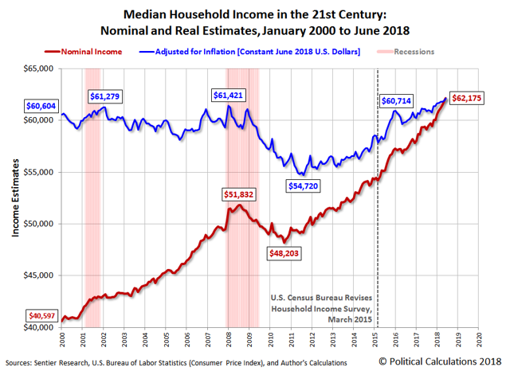
Measurement of Income Distribution
The degree of inequality or equality can be precisely measured. Through the measurement of how much income is earned by a specific segment of a population, an economist can accurately measure the income equality of a state (Jenkins, 2017). In most instances, the worker in the nation is broken down into several segments depending on the amount of income they earn. For example, if the national population is broken down into five segments that is the top 20%, the second 20%, the third 20%, the fourth 20% and lastly the bottom 20% with the details about how much money each segment earns out of the entire income of all the workers, we can be able to obtain the income distribution easily. The extent to which the income for different segments differs indicates the degree of income inequality within that particular state. The income inequality can be calculated monthly since individuals are prone of shifting from one job to another while others get promotions hence their total earnings increasing and lastly others even quit the employment sector thus contributing to income inequality moving.
The percentage of what each segment gets from the total income determines the income inequality rather than the total amount obtained by each segment. For instance, in a society with five segments, and the top segment has $120,000 income, the second $90,000 income, the third $ 60,000 incomes, the fourth $25,000 income, and the bottom $11,000 income, the percentage of each segment of the total population earnings has to be calculated for better income distribution determination (Jenkins, 2017). The averaging of the population income can be done but not much help. The total income for our above example will be the sum of the five segments average incomes that is $120,000+$90,000+$60,000+$25,000+$11,000 =$306,000. Next, the percentage of the total income of each of the segment's earnings is calculated more precisely by having each segments population being divided by the total income.
Percentage of the top segment =120,000/306,000 = 0.392 = 39.2%
Percentage of the fourth segment = 90,000/306,000 = 0.294 = 29.4%
Percentage of the third segment = 60,000/306,000 = 0.196 = 19.6%
Percentage of the second segment = =25,000/306,000 = 0.082 = 8.2%
Percentage of the bottom segment = 11,000/306,000 = 0.036 = 3.6%
The percentages indicate that the top segments of the population get more than 39% of the total population earning while the bottom segment usually acquires less than 4% of the entire population. The difference in the two segments percentages indicates that the degree of income inequality is very high. The cumulative percentage of the income distribution across all the segments should total up to 100% indicating the total income of the entire population. However, due to rounding off, the cumulative percentages may not total up to 100%. For instance, from our example, the cumulative percentages may be obtained as follows;
Cumulative percentage of bottom segment = 3.9%
Cumulative percentage of the second segment = 3.9% + 8.2% = 12.1%
Cumulative percentage of the third segment = 12.1% + 19.6% = 31.7%
Cumulative percentage of the fourth segment = 31.7% + 29.4% = 61.1%
Cumulative percentage of the top segment = 61.1% + 39.2% = 100.3%
An income distribution table may be made to precisely show the population’s income distribution. Using the income distribution table data, a Lorenz curve can be plated to give a clearer graphical income distribution of the population. Usually, the percentage of income is plotted against the percentage of population (Slottje, 2014).
Effects of Extremely Poor Distribution of Wealth
Many nations encounter themselves with the challenge of income distribution hence, most of them having their income poorly distributed. The most income I such state is from salaries and wages with a slight reinforcement of capital returns including rents and shares. The income is mostly reducing by taxation or on the other hand, increased by government transfers including child payments and pensions. Poor distribution of wealth in a nation poster great economic challenges to the nation which is the primary cause of the global financial crisis. The labor productivity of a country whose income is poorly distributed will tend to reduce significantly. Some of the impacts of poor distribution of income include;
Reduced Economic Growth. Poor distribution income will result in poverty. Poverty is generally associated with poor public health and increased crimes which poses a significant burden to the economy of that nation. The strain of mitigating all issue associated with poverty results in a decrease in the growth of government policies (Kawachi, & Subramanian, 2014). Poor distribution of income also leaves fewer people with income to invest hence there being less demand in human capital which in the long run reduces the economic growth of the state.
Decreased Education. Poor distribution of income results to segregation in schools. Children mostly influence each other in school. Researches show that the negative influences are much more than the positive impacts on the children (Brueckner, & Lederman, 2015). The segregating effects will generally cause students to perform poorly. The less successful children in school will be less productive when they start working hence reducing the productive capacity of the economy. Therefore, with improvement being made of the school completion rates, the GDP of a nation is likely to grow hence, in the long run, resulting in equal income distribution.
Economic Instability. With poor incomes distribution, the rich will tend to consume tiny portions of their incomes as compared to the poor. The rich will manage to save what the poor could have spent hence resulting to decreased aggregate demand causing more significant levels of unemployment on the future (Cheung, & Lucas, 2016). With increased unemployment, the government tries to put several measures such as lowering interest rates to stimulate demand. Government measures will result in economic instability.
Reduced Health. Research depicts that Poor distribution of income will cause poor health in the society. Individuals who are not healthy are usually associated with poor performance in their workplaces hence reducing the economy productivity capacity. People with less income are associated with higher stress instances thus causing several diseases particular mental health challenges (Kawachi, & Subramanian, 2014).
Increased Crime. According to various surveys, income inequalities are significant sources of crime within our societies. Individuals who are less disadvantaged in the community (the poor) face greater competition primarily on the scares jobs available hence, in the long run, making them engage in criminal activities (Brueckner, & Lederman, 2015). Next, law enforcement spending tends to decrease in society with poorly distributed Income. The wealthier segment of the population will have better law enforcement measures as compared to the poor segment area hence causing increase crime.
Increased Political Inequality. The concentration of income to one segment of the population tends to cause political powers to be more skewed to the wealthy segment of the population. The wealthy segment in most cases will be able to manipulate the government in corrupt and legal measures. Therefore, in a poorly distribute income population, the wealthy segment will always receive more political advantages (Dabla-Norris, et al., 2015).
Conclusion
In conclusions, income distribution is an essential microeconomic issue that determines the economic development and growth of a country. Even distribution of income in a state makes a nation to acquitter several advantages such as increased economic productivity levels, better public health, better education, reduced crime rates, political stability, improved economic growth and development, economic stability. However, a nation with uneven distribution of income will not be in the position to acquire such benefits. The government and other international agencies need always to be supportive in making the income distribution equal.

References
Brueckner, M., & Lederman, D. (2015). Effects of income inequality on aggregate output. The World Bank.
Cheung, F., & Lucas, R. E. (2016). Income inequality is associated with stronger social comparison effects: The effect of relative income on life satisfaction. Journal of personality and social psychology, 110(2), 332.
Dabla-Norris, M. E., Kochhar, M. K., Suphaphiphat, M. N., Ricka, M. F., & Tsounta, E. (2015). Causes and consequences of income inequality: a global perspective. International Monetary Fund.
Jenkins, S. (2017). The measurement of income inequality. In Economic inequality and poverty: International perspectives (pp. 17-52). Routledge.
Kawachi, I., & Subramanian, S. V. (2014). Income inequality. Social epidemiology, 126.
Slottje, D. J. (2014). The Structure of Earnings and the Measurement of Income Inequality in the US (Vol. 184). Elsevier.
Tsui, A. S., Enderle, G., & Jiang, K. (2018). Income Inequality in the United States: Reflections on the Role of Corporations.

